ERD DIAGRAM_ LOCATEBASE

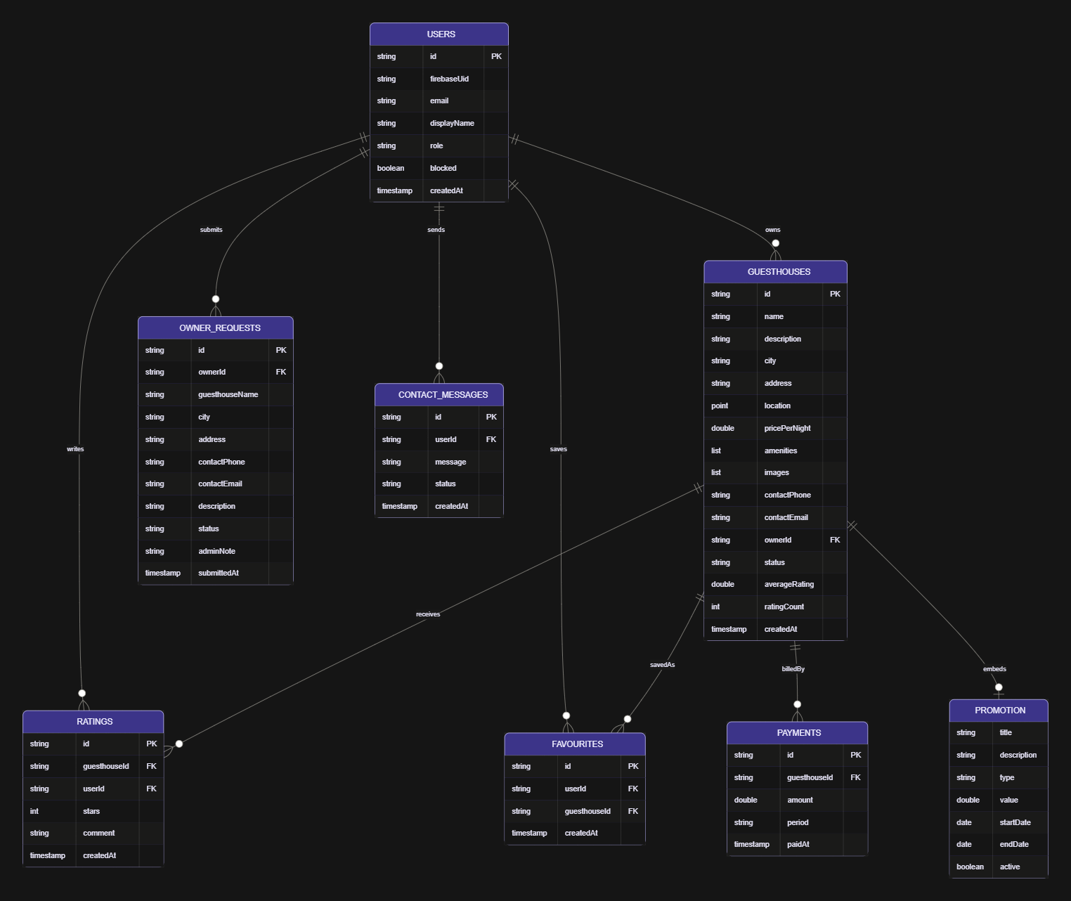

HOW THEY CONNECT

FROM | TO | RELATIONSHIP | EXPLANATION
Users | Guesthouses | One to many | One user (an owner) can own many guesthouses. Each guesthouse has exactly one owner
Users | Ratings | one to many | One user can write many ratings, one per guesthouse
Guesthouses | Ratings | one to many | One guesthouse can receive many ratings
Users | Favourites | one to many | One user can save many favourites
Guesthouses | Favourites | one to many | One guesthouse can appear in many users' Wishlist
Users and Guesthouses | Each other through favourites | many to many | Users save many guesthouses, and guesthouses are saved by many users
Users | Owner_requests | one to many | One user can submit several listing requests
Users | Contact_messages | one to many | One user can send many messages to admin
Guesthouses | Payments | one to many | One guesthouse has many payment records, roughly one per month
Guesthouses | Promotion | one to zero-or-one | A guesthouse has at most one promotion at a time, stored inside it

